# Detainment Bund©PS120 Simulator Documentation v 1.0

Contents

Detainment Bund©PS120 Simulator Documentation v 1.0 1

License 1

Introduction 2

Requirements 3

Installation instructions 5

Use of the tool 7

References 8

## License

MIT License

Copyright © 2024 Fernando Avendaño Veas

Permission is hereby granted, free of charge, to any person obtaining a copy of this software and associated documentation files (the "Software"), to deal in the Software without restriction, including without limitation the rights to use, copy, modify, merge, publish, distribute, sublicense, and/or sell copies of the Software, and to permit persons to whom the Software is furnished to do so, subject to the following conditions:

The above copyright notice and this permission notice shall be included in all copies or substantial portions of the Software.

THE SOFTWARE IS PROVIDED "AS IS", WITHOUT WARRANTY OF ANY KIND, EXPRESS OR IMPLIED, INCLUDING BUT NOT LIMITED TO THE WARRANTIES OF MERCHANTABILITY, FITNESS FOR A PARTICULAR PURPOSE AND NONINFRINGEMENT. IN NO EVENT SHALL THE AUTHORS OR COPYRIGHT HOLDERS BE LIABLE FOR ANY CLAIM, DAMAGES OR OTHER LIABILITY, WHETHER IN AN ACTION OF CONTRACT, TORT OR OTHERWISE, ARISING FROM, OUT OF OR IN CONNECTION WITH THE SOFTWARE OR THE USE OR OTHER DEALINGS IN THE SOFTWARE.

**Citation:** Avendaño, F.A. 2024. Detainment Bund (c)PS120 Simulator Documentation, Version 1.0. (July 2024).

## Introduction

The Detainment Bund©PS120 simulator (DB simulator hereafter), which comprises a set of processing algorithms written in Python, is intended to help users identify potential suitable locations in a catchment area where a Detainment Bund©PS120 (similarly known as WASCOBs in the U.S.) could be constructed.

Both WASCOBs, water and sediment control basins, and Detainment Bund©PS120 (‘detainment bund’ or ‘DB’ hereafter), which is a specific type of detainment bund, are similar concepts, where an embankment is built in gullies and flow pathways that are not perennial to reduce sediment and nutrient concentrations. However, DB have a limited period of holding water for a maximum of three days and are generally constructed in depressions where the ratio of simulated storage volume to contributing catchment area is >120:1. Catchment studies in the North Island of New Zealand have shown that the use of DBs with a storage volume to catchment area ratio of >120:1 show promising results in terms of cost-effectiveness and efficacy for reducing suspended sediments and nutrient (nitrogen and phosphorus) losses in storm runoff events when water is held for a maximum of three days in a row (Figure 1) (Levine et al., 2017, Clarke et al., 2013). Holding water for this period of time has been demonstrated to not compromise pasture productivity and could be more suitable for use in the predominant land use of New Zealand.

**Figure 1.** Diagram of a Detainment Bund©PS120 (adapted from: Levine et al., 2021)

The development of the DB simulator stems from the necessity of providing a free and accessible version of the adapted ACPF toolbox v. 5.0, developed by the Agricultural Conservation Planning Framework (ACPF) project (Porter et al., 2023) (<https://acpf4watersheds.org/>), to map and locate DBs in agricultural landscapes. Most of the work and know-how (i.e., geoprocessing steps and further programming) has been done by the people involved in the ACPF project. However, in the DB simulator I have incorporated the calculations of the design criteria of a DB storage volume to catchment area ratio, which has been suggested by Paterson (2019). The tool ranks potential DB catchments based on this calculation, facilitating the selection of suitable sites according to Paterson’s criteria (storage:catchment ratio > 120:1) (Paterson, 2019). I have also adapted the WASCOBS tool from the ACPF toolbox v. 5.0, which is currently compatible with ArcGIS, as the DB simulator which can be run with open-source QGIS.

This toolbox was adapted and developed by Fernando Avendaño Veas ([F.Avendano@massey.ac.nz](mailto:F.Avendano@massey.ac.nz)) in July 2024.

## Requirements

* Long Term Release QGIS software version 3.22.5 'Białowieża' to 3.34.8 ‘Prizren’
* Stream order package from GRASS (‘r.stream.order’)
* Stream basin package from GRASS (‘r.stream.basin’)
* The latest version of TauDEM (optional)

To download QGIS software please visit the official’s website and install the Long-Term Release version ‘3.34.8 Prizren LTR’: <https://qgis.org/resources/installation-guide/>

You can download and install the packages ‘r.stream.order’ and ‘r.stream.basin’ from GRASS GIS, once QGIS has downloaded by opening the GRASS GIS app (located generally in the OSGeo4W folder in the Start menu).

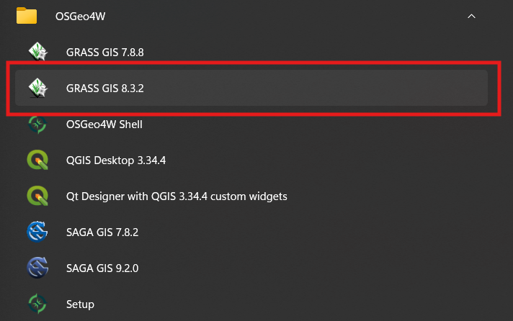

Once here, head to the ‘Settings’ tab -> ‘Addons extension’ -> ‘Install extension from addons’.

In the new panel, search for ‘r.stream’ in the ‘Search’ field and download both ‘r.stream.order’ and ‘r.stream.basins’.

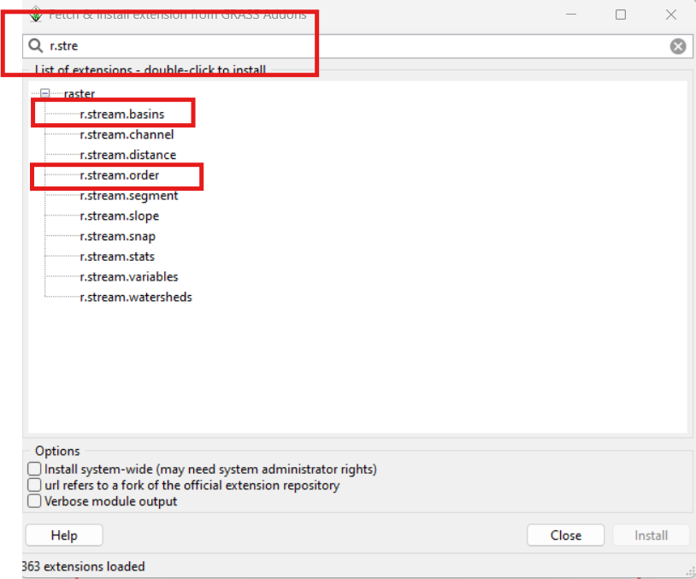

Once installed, you will be required to manually add the description files (.txt) provided with this tool into the QGIS folder (generally ‘C:\Program Files\QGIS X.XX’). Search for the directory ‘~\apps\qgis-ltr\python\plugins\grassprovider\description’ and paste the ‘r.stream.order.txt’ and ‘r.stream.basins.txt’ description files here. If you cannot find the previous directory, try the directory ‘~\apps\qgis-ltr\python\plugins\processing\algs\grass7\description’.

Finally, search for the recently added addons in your local directory (generally ‘C:\Users\[your_username]’ and find ‘~\AppData\Roaming\GRASS7\addons\bin’. Copy these files into your local QGIS directory folder (generally ‘C:\Program Files\QGIS X.XX’) and find the directory ‘C:\Program Files\QGIS 3.22.12\apps\grass\grass83\bin’. The names of the folder may vary depending your version of GRASS and QGIS.

Though it is not strictly necessary for this tool, the TauDEM tool can be useful and downloaded from:

<https://hydrology.usu.edu/taudem/taudem5/downloads.html>

## Installation instructions

1. To start using this set of scripts, start your project in QGIS, click on the ‘Toolbox’ icon (gear icon as shown in the figure below) and search for the ‘Options’ icon (spanner icon as shown in the figure below).

1. Click on the ‘Scripts’ dropdown and double click on the space next to ‘Script folder(s)’



1. A ‘three dots’ button will appear on the right site, which you can click on.



1. In the new panel, select ‘Add’ and navigate to the folder containing the set of scripts and then select it and click ‘OK’.

1. A new toolset called ‘DB simulator’ should appear on the right-side panel in the Processing Toolbox

## Use of the tool

This tool is an adaptation and works very similarly to the ‘WASCOB’ and ‘WASCOB basins’ tools from the ACPF toolbox v. 5.0. Detailed information on how to use the tool and the theory behind each step can be found in the ACPF project’s official website and their Youtube channel:

<https://www.youtube.com/watch?v=8gPCEqZNfcQ&list=PLVTmFFu20my3VPTXWQ4MBDTxF84G-PdV8>

To use the DB simulator tool, it is highly recommended to follow the instructions provided here: https://www.youtube.com/watch?v=ZEVFelN4Gi8. The names of each Python script have been kept the same or very similar to the original ACPF toolbox v. 5.0 for consistency and make it easier to follow the instructions. Further information can be found also in the ACPF toolbox documentation (Porter et al., 2023):

<https://acpf4watersheds.org/wp-content/uploads/sites/407/2023/05/Agricultural-Conservation-Planning-Toolbox-UsersManual_v5.0.pdf>

Since geoprocessing tools are different between different GIS systems, this tool might take longer time to produce results compared to the original ACPF toolbox.

## References

Clarke, D. T., Paterson, J., Hamilton, D., Abell, J., Scarsbrook, M., Thompson, K., Moore, R., Bruere, A. (2013) Overview of using Detainment Bunds for mitigating diffuse-source phosphorus and soil losses for pastoral farmland. In: Accurate and efficient use of nutrients on farms. (Eds L.D. Currie and C L. Christensen). Occasional Report No. 26. Fertilizer and Lime Research Centre, Massey University, Palmerston North, New Zealand. 9 pages. https://www.massey.ac.nz/~flrc/workshops/13/paperlist13.htm

Levine, B., Paterson, J. and Burkitt, L., (2017). Phosphorus Mitigation Project; mitigation of surface P runoff using Detainment Bunds. In: Science and policy: nutrient management challenges for the next generation. (Eds L. D. Currie and M. J. Hedley). http://flrc.massey.ac.nz/publications.html. Occasional Report No. 30. Fertilizer and Lime Research Centre. Massey University, Palmerston North. New Zealand. 7 pages.

Levine, B., Horne, D., Burkitt, L., Tanner, C., Sukias, J., Condron, L., & Paterson, J. (2021). The ability of detainment bunds to decrease surface runoff leaving pastoral catchments: Investigating a novel approach to agricultural stormwater management. Agricultural Water Management, 243, 106423.

Paterson, J.H. (2019). The DB Applicability Model: A GIS model for assessing catchments’ suitability for the installation of Detainment BundsPS120 to mitigate storm water runoff. Available: https://atlas.boprc.govt.nz/api/v1/edms/document/A3262395/content

Porter, S.A., M.D. Tomer, D.E. James, and J.D. Van Horn. (2023). Agricultural Conservation Planning Framework: ArcGIS®Toolbox User’s Manual, Version 5. ACPF National Hub, Iowa Water Center, Iowa State University, Ames Iowa. Available: https://acpf4watersheds.org/ (April, 2023)